


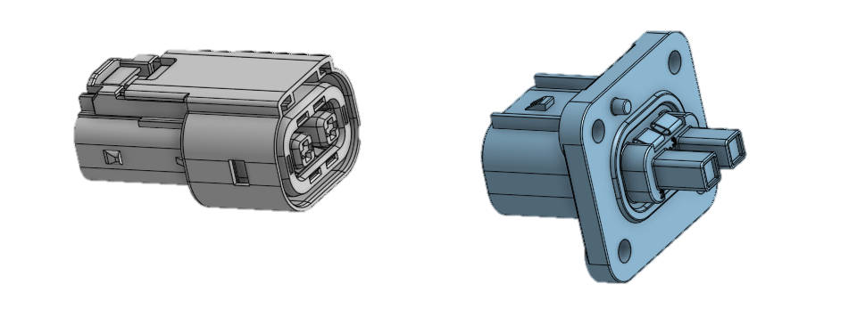
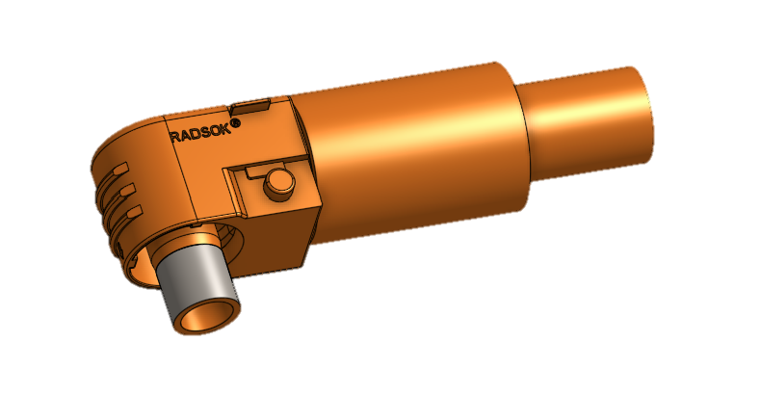
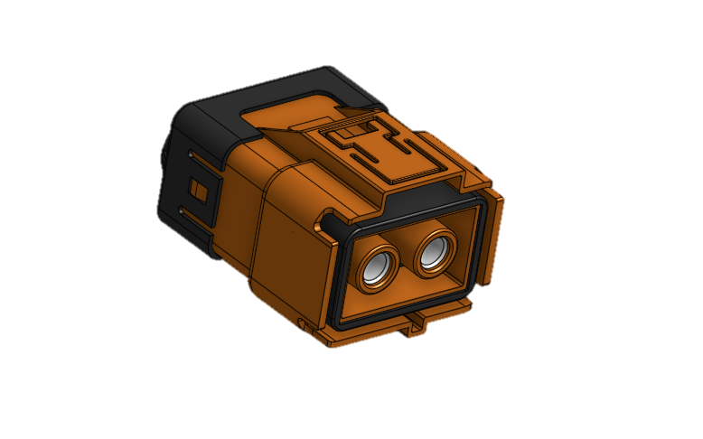
ZERO-TO-HERO

How To Crimp NU25 HV Connectors
Jacob Lukes
2025

Contents
Sanity Checks 2
HIP to Motor Controller 2
SLPPB50BSO0EH / SLPPB50BSO1EH 2
HIP to DCDC/Energy Meter 7
2103124-4 7
4-2103177-4 7
HIP to Accumulator 7
ELPA2A2510 7
Tools 8
Scissors 8
Cable Shears 8
Blue Handle Cable Crimpers 9
Stanley Knife 9

Sanity Checks
- Ensure all components needed for crimping the connectors are present
- Make double sure the crimp needs to happen
- Ensure correct crimp orientation of connectors

HIP to Motor Controller

SLPPB50BSO0EH / SLPPB50BSO1EH
- SLPPB50BSO0EH is a 90-degree keyway connector
- SLPPB50BSO1EH is a 270-degree keyway connector
- Ensure the following components are present (see Figure 1, part A)
  - Connector
  - Inner copper adaptor
  - Not glue-lined Heat-shrink
  - Glue-lined heat-shrink
  - Rubber gromet
  - Plastic cable ring
  - Cable retainer
- Step 0
  - Check rotation of connector when it is crimped to cable (permanent marker is suggested to get this right)
- Step 1
  - Thread on components in this order (see Figure 1, part B):
    - Cable retainer (ensure facing correct direction)
    - Plastic cable ring
    - Rubber gromet
    - Not glue-lined heat-shrink
    - Glue-lined heat-shrink
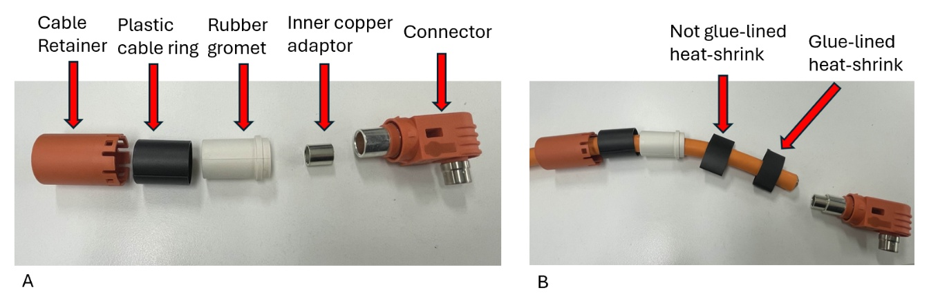
Figure 1

- Step 2
  - Strip back 28 mm of outer insulation, using either a knife (refer to: Stanely Knife ) or a cable stripping tool
  - Cut off and shorten outer foil shield down to the end of the outer insulation
  - Carefully and slowly unbraid wire shielding
  - Once unbraided, use scissors (refer to: Scissors ) to shorten back the wire shielding back to the original 28 mm length (see Figure 2)
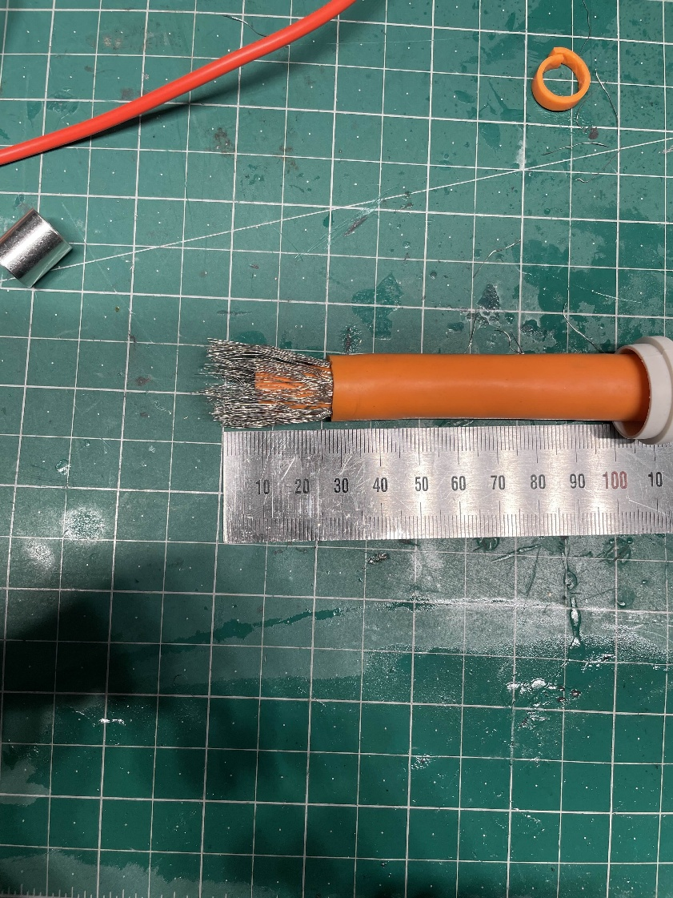
Figure 2
- Step 3
  - Using cable shears (refer to: Cable Shears), cut off 10 mm of the inner copper and insulation (as seen in Figure 2 and Figure 3)
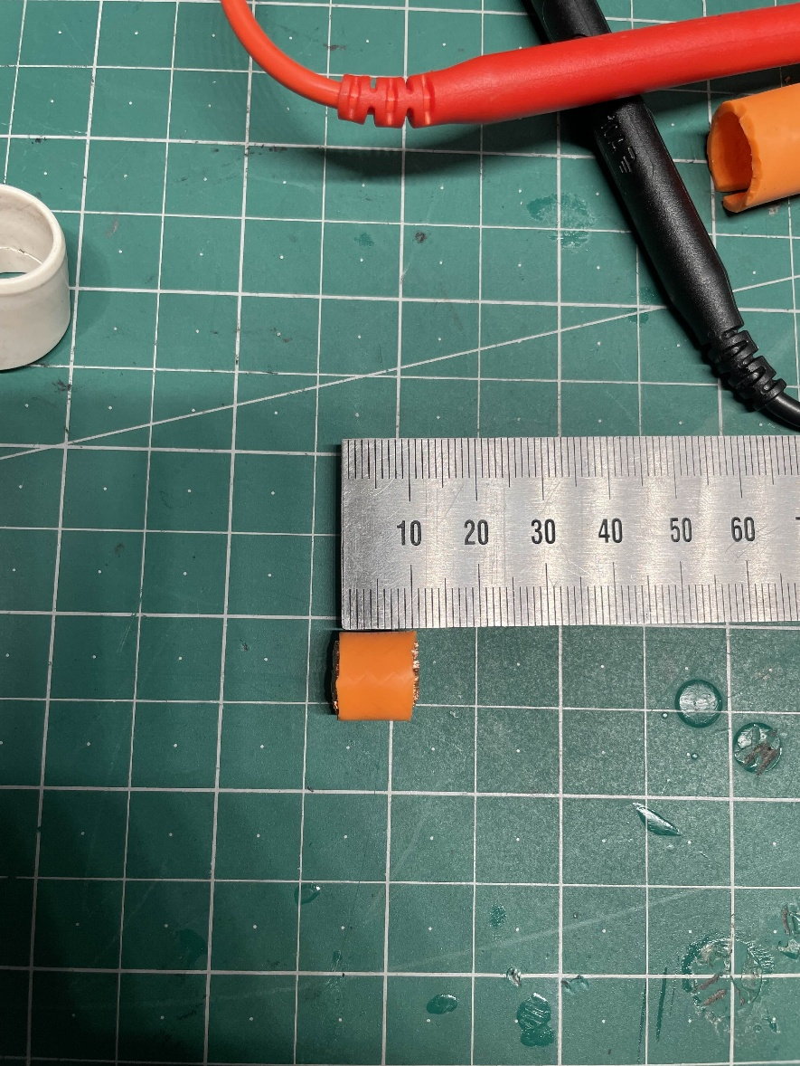
Figure 3

- Step 4
  - Curl back the wire shielding
  - Strip back 15 mm of the inner copper core insulation, using a Stanely Knife
  - Insert inner copper adaptor
  - See Figure 4
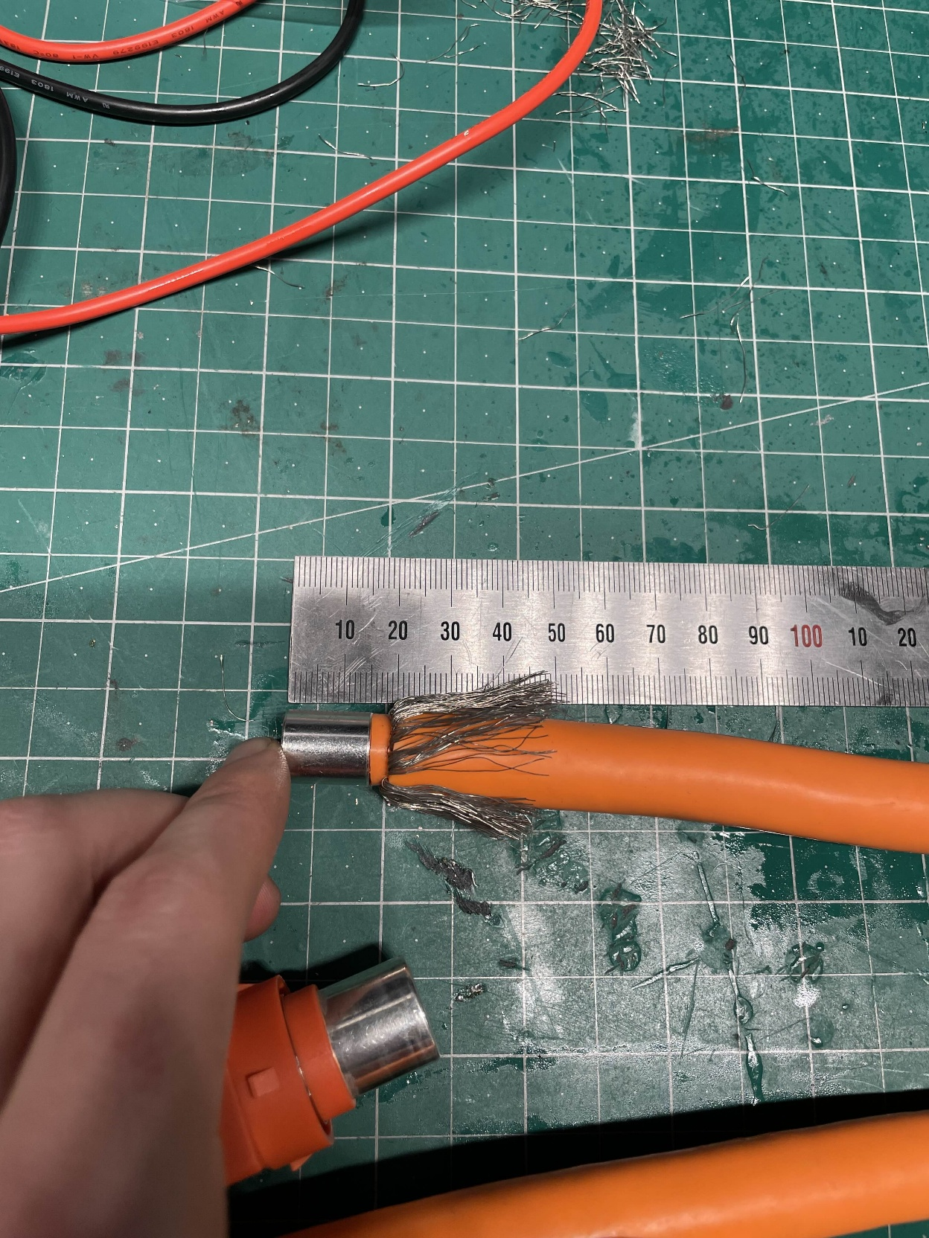
Figure 4
- Step 5
  - Insert and crimp the connector to the copper
  - Use the big Blue Handle Cable , on the 95 mm setting, see Figure 5
    - Figure 6 shows what happens if 70 mm setting is used
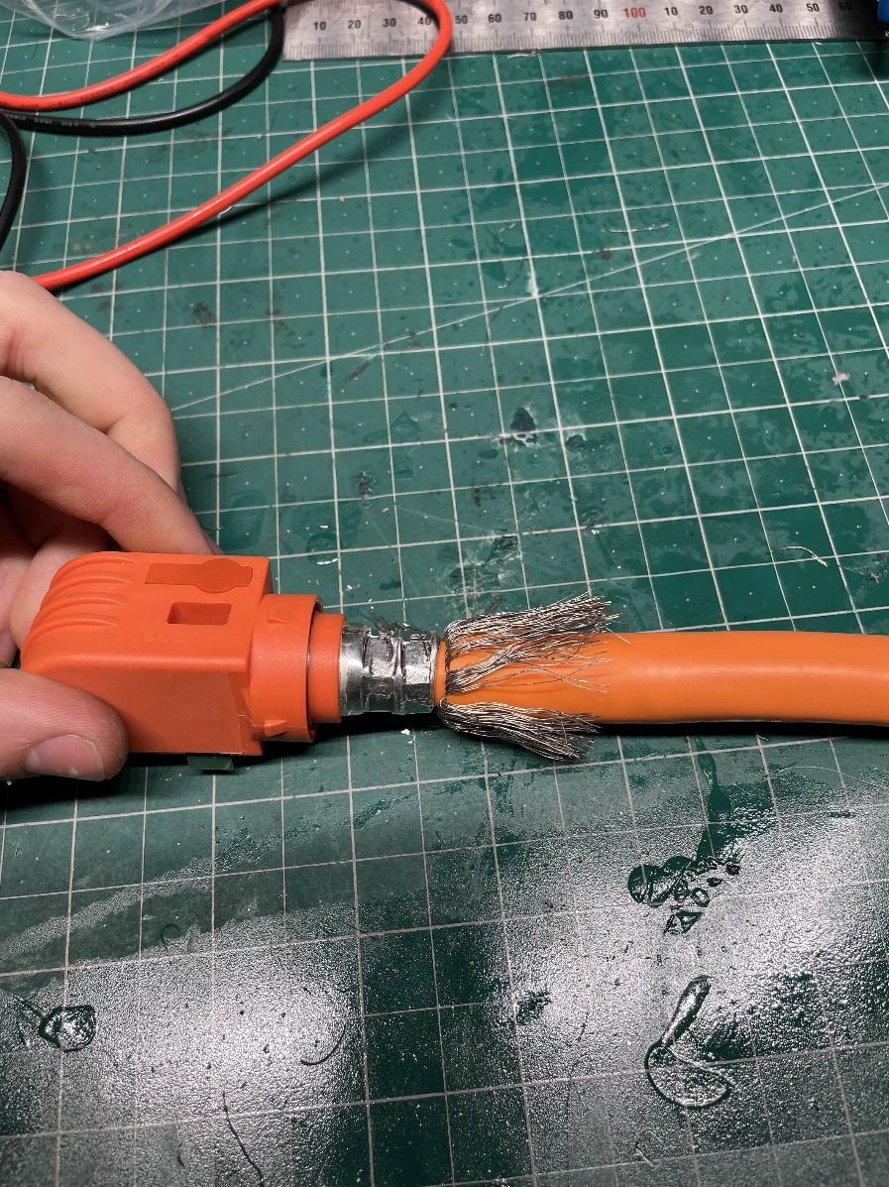
Figure 5
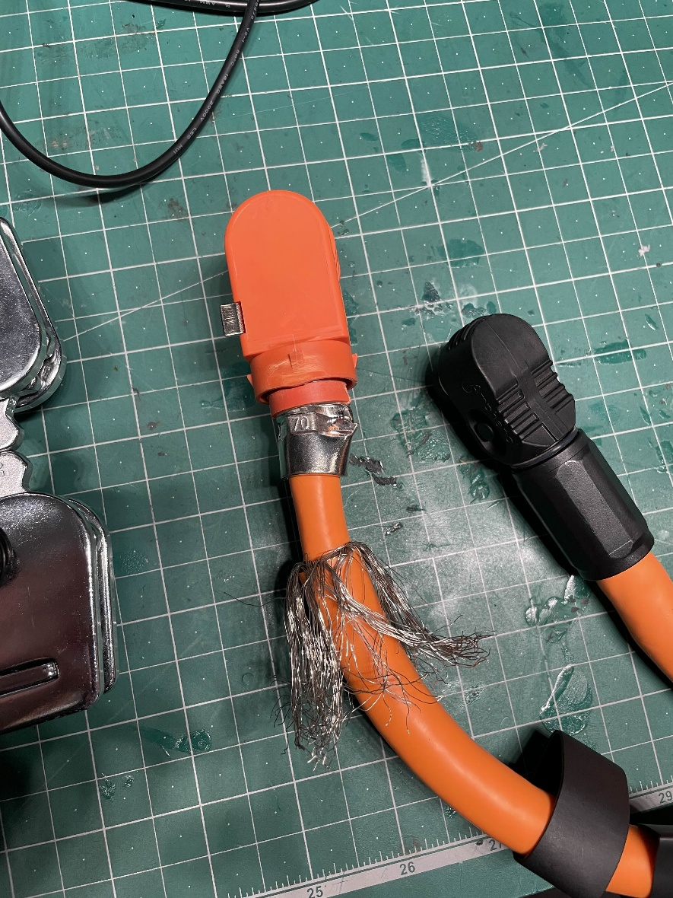
Figure 6

- Step 6
  - Thread the glue-lined heat-shrink over the wire shielding to cover the crimp
    - See Figure 7, part A
  - Ensure that the crimp and the shielding are not touching
    - If they do touch after the heat shrink is shrunk down, then when it goes on the car there will be an IMD fault, due to HV and LV ground touching. You’ll be chasing your tail for hours
  - Heat-shrink it down
    - Heat gun at ~250 °C, with second or third flow rate setting
  - Figure 7 part B and C show how the crimp and shield wires are not touching
    - The outer insulation and shielding may need to be pulled down to ensure that the wire shield and crimp are not touching
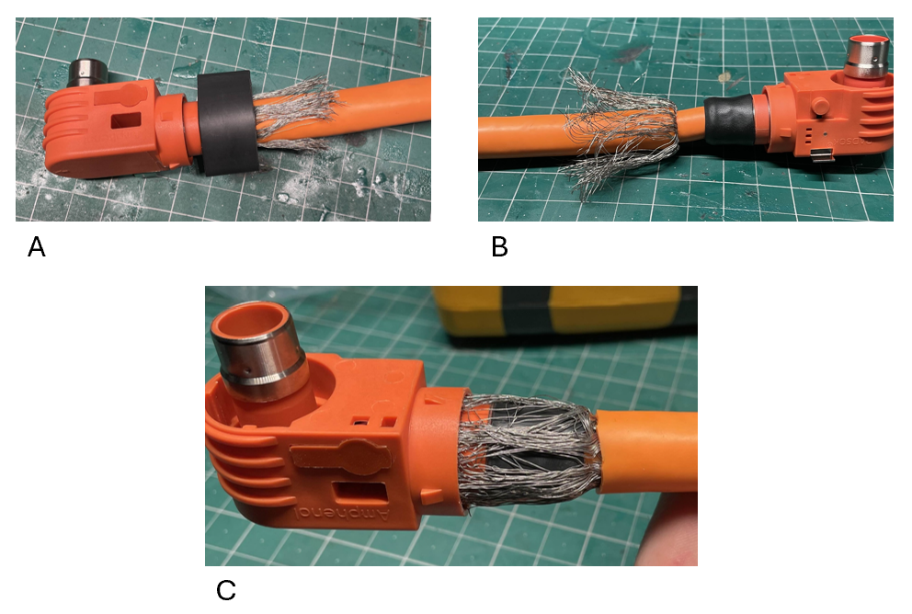
Figure 7
- Step 7
  - Bring up and shrink down the not glue-lined heat-shrink, to cover and secure the wire shielding, refer to Figure 8
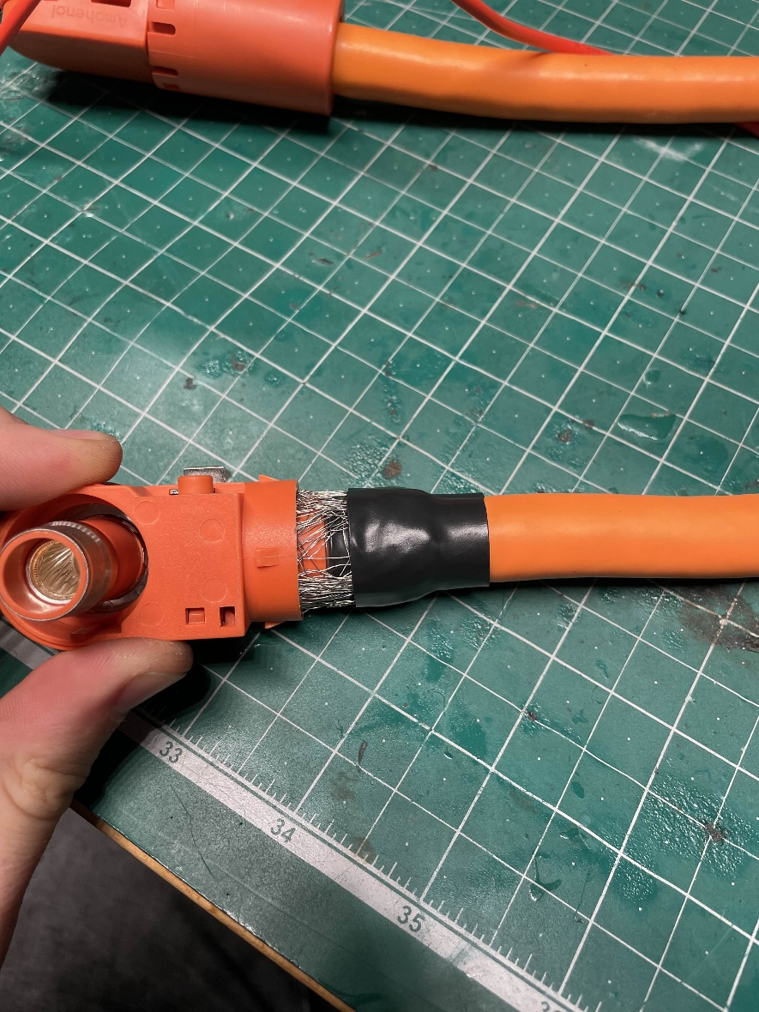
Figure 8

- Step 8
  - Bring up rubber gromet, see Figure 9
  - You may need to cut and comprise this gromet, depending on how Step 10 goes
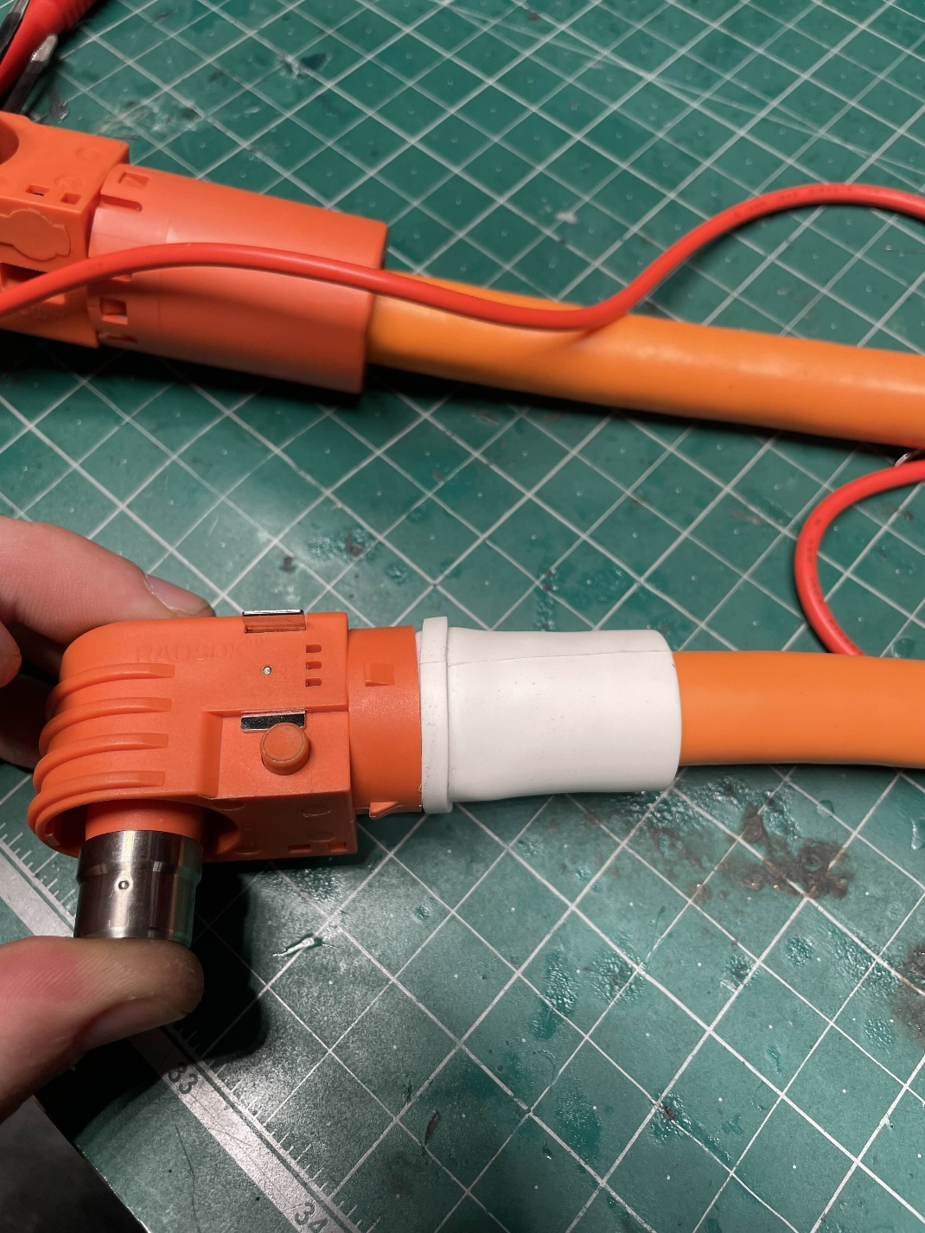
Figure 9
- Step 9
  - Bring up plastic cable ring to cover rubber gromet
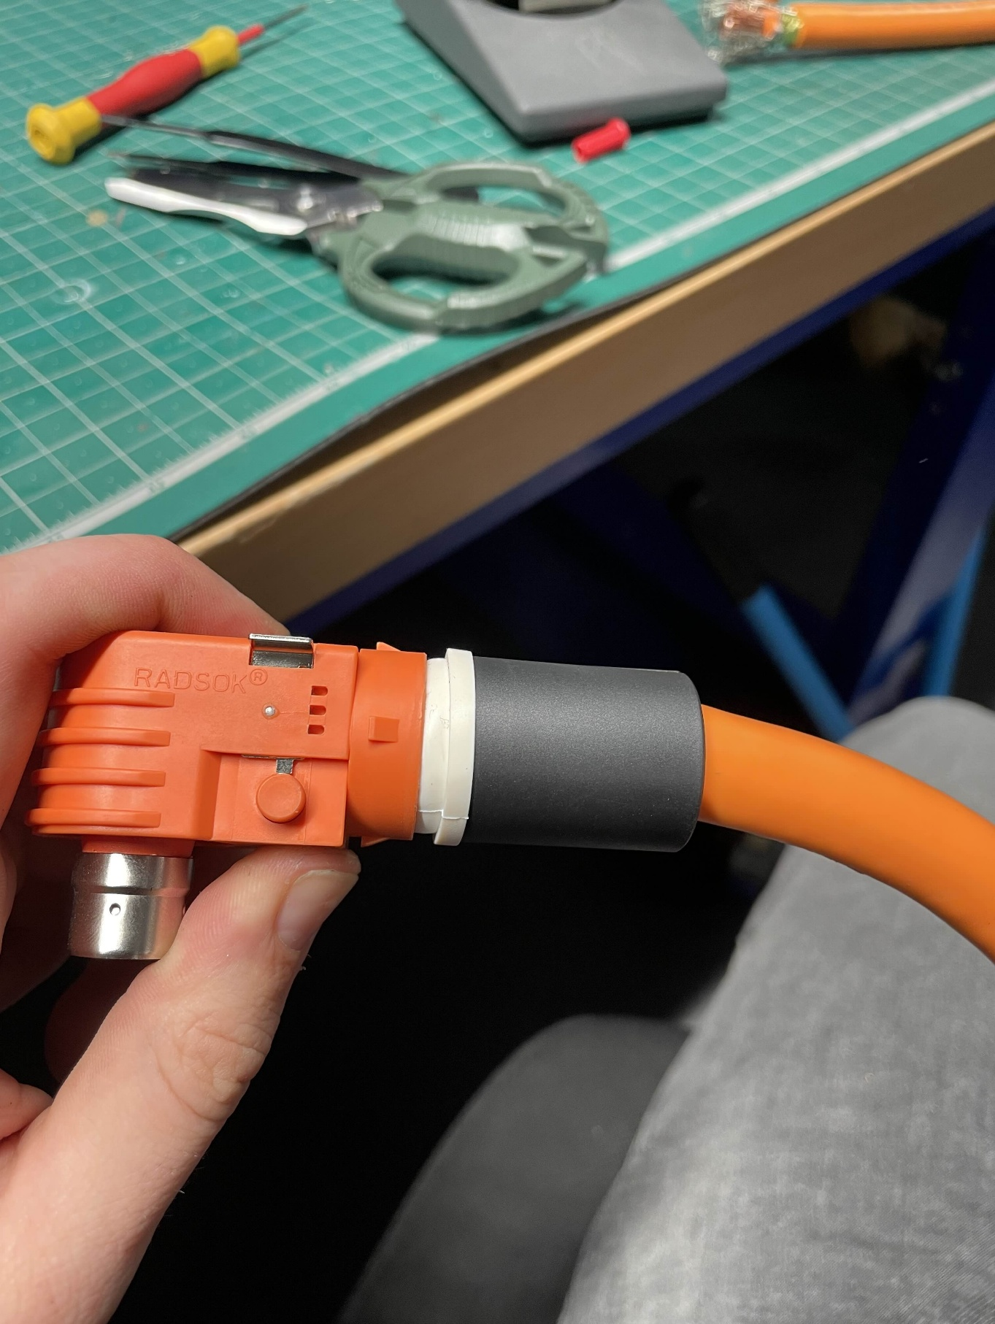
Figure 10

- Step 10
  - Bring up the cable retainer, ensure that it comes up far enough for the clips to click in (refer to Figure 11 for the clips in question)
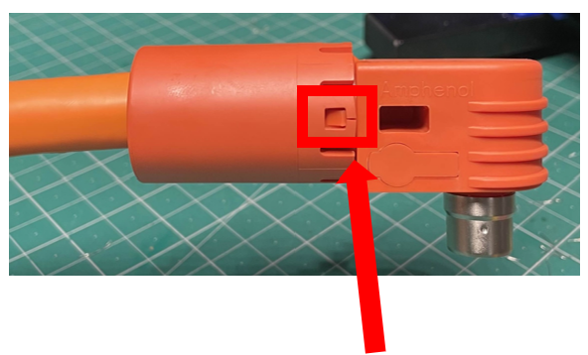
Figure 11
  - This part will most likely take a lot of force, if there is no hope of it working, go back to Step 8 and cut/’comprise’ the gromet, so that when the cable retainer is pushed up, the gromet will break inside of it. This should allow the retainer to easily clip up
  - See Figure 12 for the completed assembly
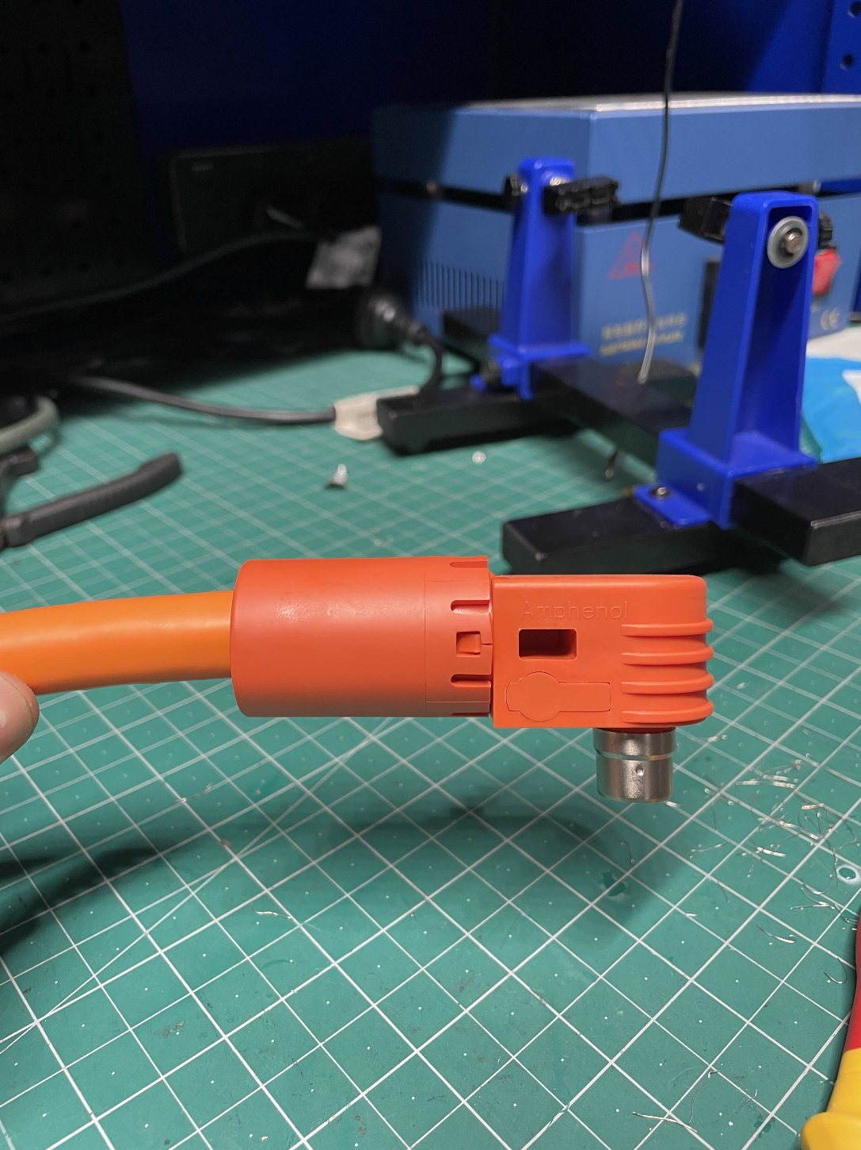
Figure 12

HIP to DCDC/Energy Meter

2103124-4

4-2103177-4

HIP to Accumulator

ELPA2A2510

Tools

Scissors
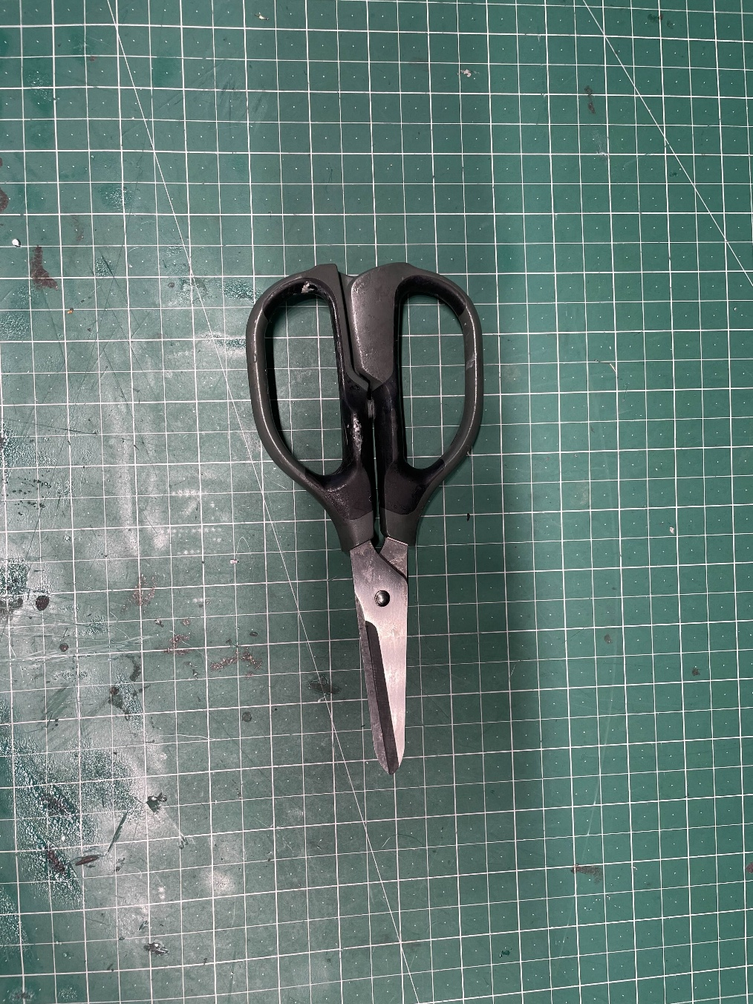
Figure 13 Scissors

Cable Shears
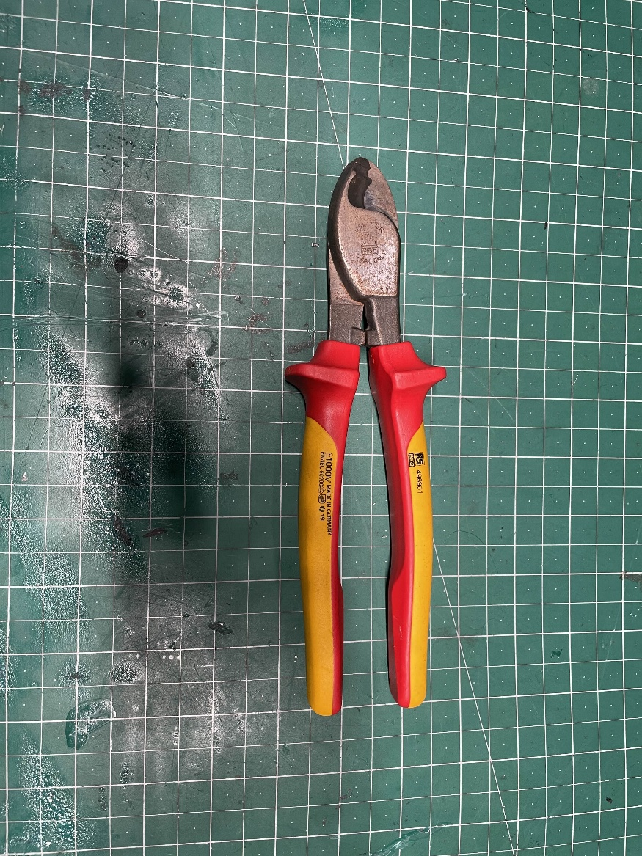
Figure 14 Cable Shears

Blue Handle Cable Crimpers
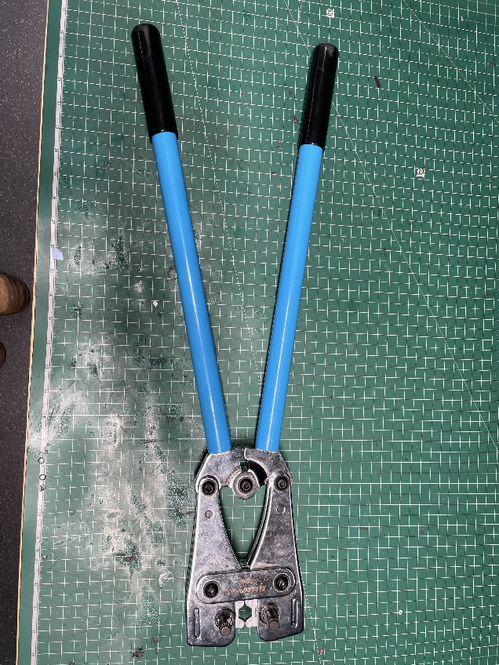
Figure 15 Blue Handle Cable Crimpers

Stanley Knife
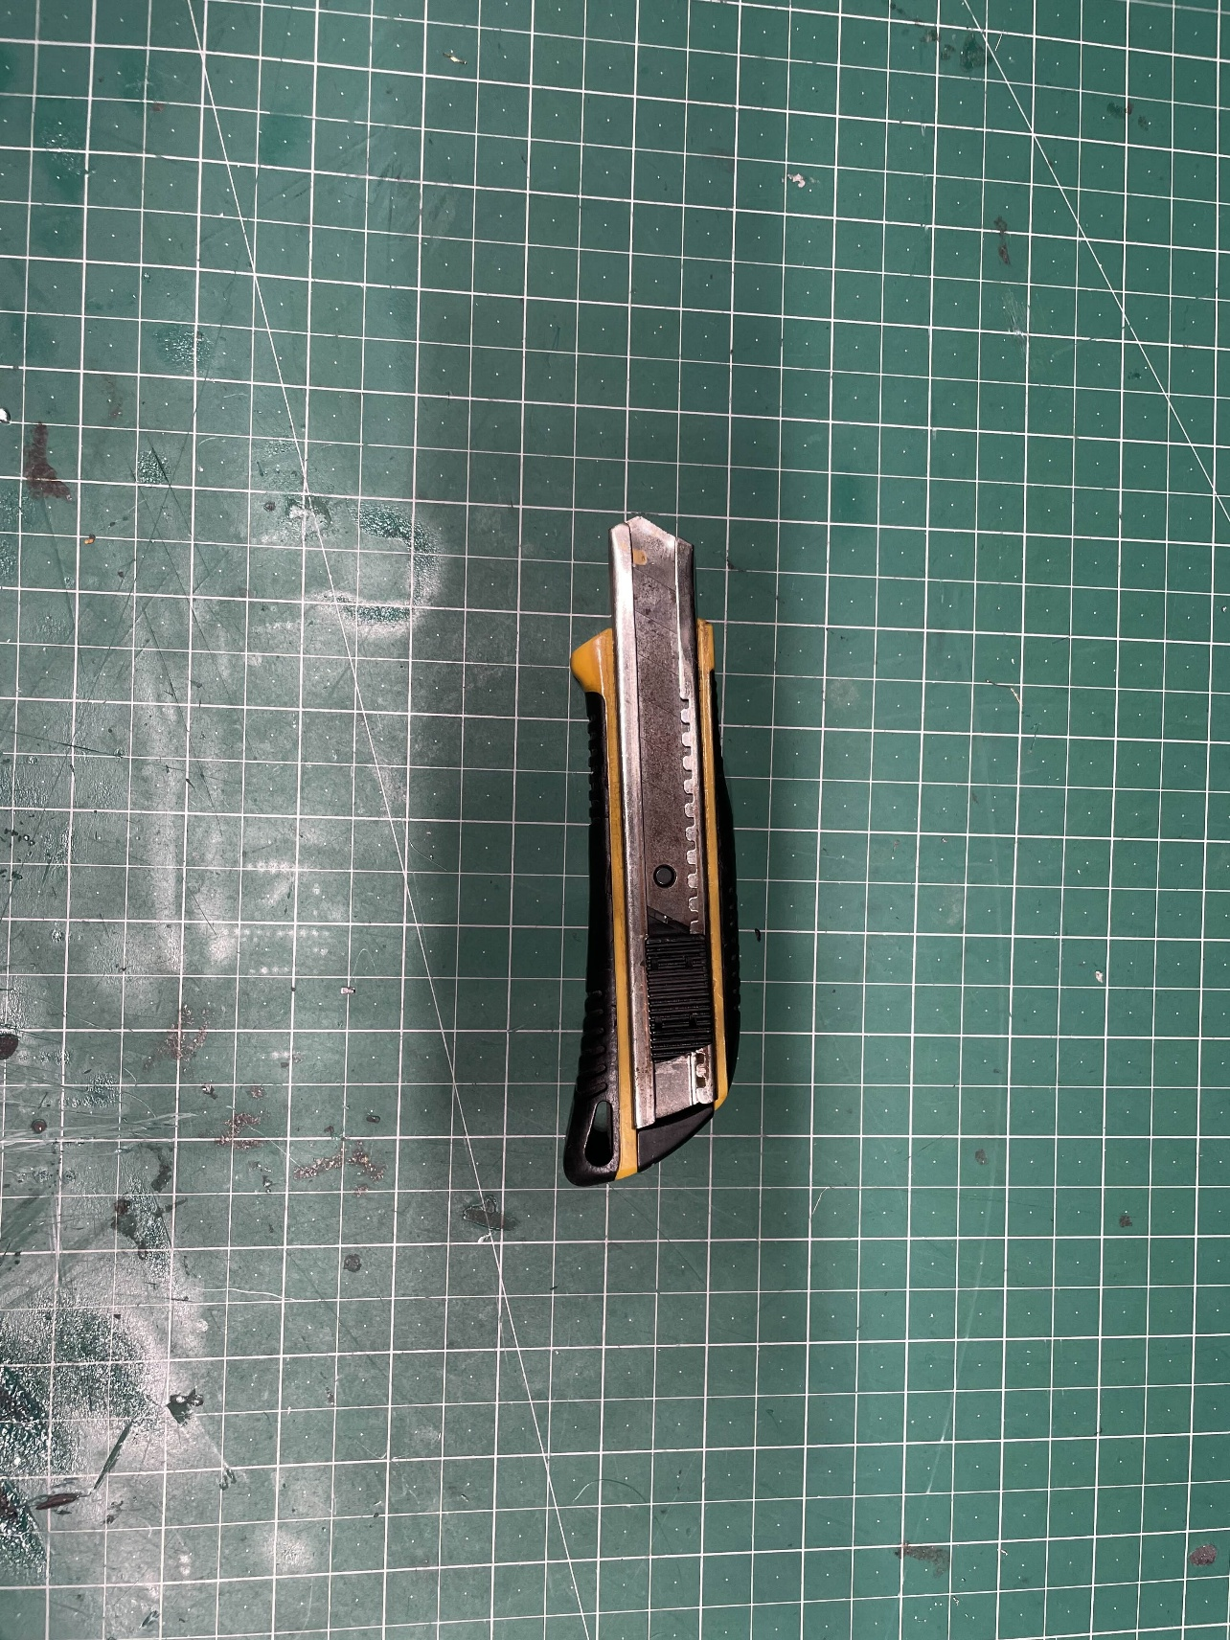
Figure 16 Stanely Knife

